

**NET320-Database Systems**

**SWS213-Database Design**

**Spring ‘18**

**Lab 6- Relationship between tables**

CLO2 Design and implement a database solution based on a given business scenario

|  |  |  |
| --- | --- | --- |
| Task 1-10 pts | Task 2-30 pts | Total PTS |
|  |  |  |

**Name:**

**ID:**

**Objective of the Lab**

Upon successful completion of this lab the student will be able to:

* Understand one to many relationships.
* Foreign key to connect multiple tables
* Various Queries

**Grading**

Task 1- 10 pts

Task 2 - 30 pts

* Q1 and Q2 carries 4 pts
* Q3 to Q 13 carries 2 pts

**Software Required**

* **MySQL SERVER**
* **WORKBENCH**

**Notes**

* Students should upload the model to moodle.
* Save the model with your name followed by “Lab6”
* Deadline 06 March 6, 2018 – 18:00PM

**Task 1- 10 pts**

**Step 1**

Create a database in SQL. Use the EER diagram to create the tables and details.

Name the schema as Hospital.

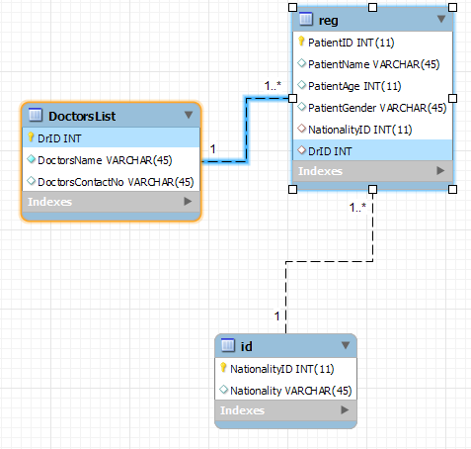

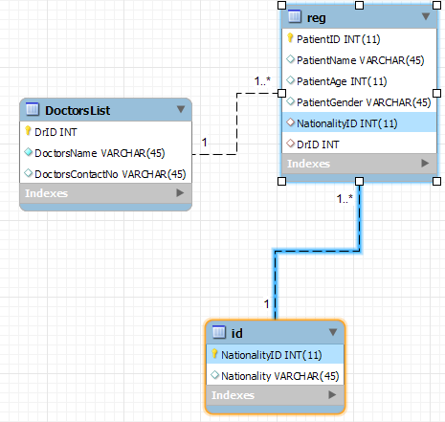

**Step 2**

1. Save the model to desktop as Hospital_youridnumber.
2. Create a server called HospitalServer.
3. Fill the ‘reg’ table with the details.

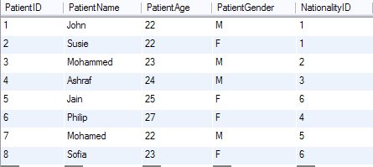

1. Fill the tables with the below details.

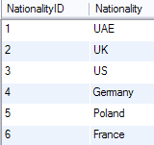 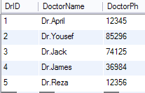

**Task 2- 10 pts**

Questions:-

1. What are the datatypes used for 4 pts

PatientName- VARCHAR(45)

Nationality-VARCHAR(45)

1. What are the foreign keys used? 4 pts

DrID and NationalityID in the table reg that correspond to primary keys DrID in DoctorsList and NationalityID in id respectively.

1. What is the query to display all details from Reg and ID tables? 2 pts

SELECT * FROM hospital.reg, hospital.id WHERE reg.NationalityID = id.NationalityID;

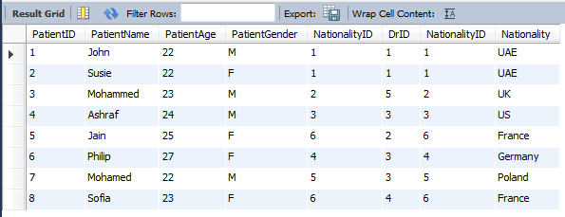

1. What is the query to display all Patient Names and their Nationalities? 2 pts

SELECT PatientName, Nationality FROM hospital.reg, hospital.id WHERE reg.NationalityID = id.NationalityID;

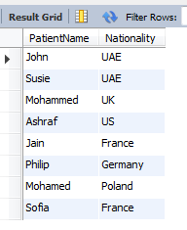

1. What is the query to display all details of patients whose Nationality is France? 2 pts

SELECT PatientID, PatientName, PatientAge, PatientGender, DrID

FROM hospital.reg, hospital.id

WHERE reg.NationalityID = id.NationalityID AND Nationality = 'France';

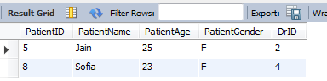

1. What is the query to display all details from 3 tables? 2 pts

SELECT *

FROM hospital.reg, hospital.id, hospital.doctorslist

WHERE reg.NationalityID = id.NationalityID AND reg.DrID = doctorslist.DrID;

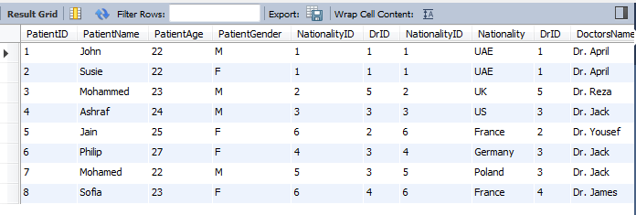

1. What is the query to display the Patient Names and their respective doctors names? 2 pts

SELECT PatientName, DoctorsName

FROM hospital.reg, hospital.doctorslist

WHERE reg.DrID = doctorslist.DrID;

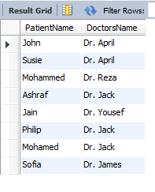

1. What is the query to display the Patient Names and their respective doctor is Dr.April? 2 pts

SELECT PatientName, DoctorsName

FROM hospital.reg, hospital.doctorslist

WHERE reg.DrID = doctorslist.DrID AND DoctorsName = 'Dr. April';

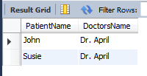

1. What is the query to display the Patient Names and their age who are from Germany? 2 pts

SELECT PatientName, PatientAge

FROM hospital.reg, hospital.id

WHERE reg.NationalityID = id.NationalityID AND Nationality = 'Germany';



1. What is the query to display the PatientName , age and their doctors name who are in the age of 22? 2 pts

SELECT PatientName, PatientAge, DoctorsName

FROM hospital.reg, hospital.doctorslist

WHERE reg.DrID = doctorslist.DrID AND PatientAge = 22;

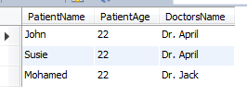

**Insert**

Try the below Query to insert the details of Yousef with age 21, gender male and NationalityID 5 (Poland) and DrID 1 (Dr.April)

INSERT INTO `hospital`.`reg` (`PatientID`, `PatientName`, `PatientAge`, `PatientGender`, `NationalityID`, `DrID`) VALUES ('9', 'Yousef', '21', 'M', '5', '1');

1. Now write down the query to display all patients names with Dr.April. 2 pts

SELECT PatientName

FROM hospital.reg, hospital.doctorslist

WHERE reg.DrID = doctorslist.DrID AND DoctorsName = 'Dr. April';

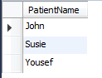

1. What is the query to display the Dr. James and Dr. Jack’s patients with their ages. 2 pts

SELECT PatientName, PatientAge

FROM hospital.reg, hospital.doctorslist

WHERE reg.DrID = doctorslist.DrID AND DoctorsName IN ('Dr. James', 'Dr. Jack');

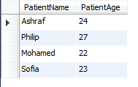

1. What is the query to insert a new patient with Name Ash with nationality Germany. Her doctor is Dr.Jack and she is in age 22. 2 pts

INSERT INTO `hospital`.`reg`

(`PatientID`, `PatientName`, `PatientAge`, `PatientGender`, `NationalityID`, `DrID`)

VALUES (10, 'Ash', 22, 'M', 4, '3');

